SRM INSTITUTE OF SCIENCE AND TECHNOLOGY FACULTY OF COMPUTER SCIENCE AND ENGINEERING DEPARTMENT OF COMPUTER SCIENCE
RAMAPURAM , CHENNAI



21LEM202T-UNIVERSAL HUMAN VALUES: UNDERSTANDING HARMONY AND ETHICAL HUMAN CONDUCT

CASE STUDY REPORT ON

VISIT TO OLD AGE HOME : BRINDHAVAN TRUST

Submitted By:
CSE/F[II/IV]

MOGARALA JAHNAVI [RA2411003020351]

PRATHIKSA G[RA2411003020373]

Under The Guidance of

Dr. N. Karunagaran, AP/Physics
(Assistant Professor, Department of Computer Science and Engineering)

Content | Mark Split Up | Marks Scored
Abstract | 2 Marks
Awareness about yourself and the Surroundings (Family, Society &Nature) | 4 Marks
Socially Responsible Behaviour/ Environmentally Responsible work with Proof | 5 Marks
Understanding of Ethical Human Values , Human Relationship and Society | 4 Marks
Appreciation and Gratitude | 3 Marks
Summary | 2 Marks
Total | 20 Marks

SRM INSTITUTE OF SCIENCE AND TECHNOLOGY FACULTY OF COMPUTER SCIENCE AND ENGINEERING

BONAFIDE CERTIFICATE

This is to certify that this is the bonafide record work done by Mogarala Jahnavi and Prathiksa G of Registration Number RA2411003020351 and RA2411003020373 respectively in the course of 21LEM202T / UNIVERSAL HUMAN VALUES from the Department of Computer Science and Engineering at SRM Institute of Science and Technology, Ramapuram Campus during the academic year 2025-2026.

SIGNATURE
Dr. N. Karunagaran Assistant Professor/Physics

INDEX OF THE CONTENT

S.NO | TOPICS | PAGE NO
1 | ABSTRACT | 1
2 | INTRODUCTION | 1-2
3 | AWARENESS ABOUT YOURSELF AND SURROUNDINGS | 3
4 | SOCIAL AND ENVIRONMENTAL RESPONSIBILITY | 5
5 | UNDERSTANDING ETHICAL VALUES | 8
6 | ENGAGING IN SOCIAL WORK | 10
7 | PROOF OF WORK | 11-12
8 | APPRECIATION AND GRATITUDE | 3
9 | SUMMARY | 14

CASE STUDY

Visit to an old-age home

BRINDHAVAN TRUST is a dedicated old age home committed to providing quality care and support for the elderly. The institution focuses on the overall well-being of its residents by addressing their physical, emotional, and spiritual needs. It strives to create a safe and nurturing environment where senior citizens can live with dignity, respect, and comfort.

The trust believes in treating every resident as a valued individual and ensures that they receive personalized attention and care. The staff members are compassionate and attentive, working consistently to provide a home-like atmosphere that promotes a sense of belonging and security. Facilities are well-maintained, and efforts are made to ensure cleanliness, proper nutrition, and medical support for the residents.

In addition to meeting basic needs, Brindhavan Trust also emphasizes emotional well-being by encouraging interaction, companionship, and engagement in daily activities. This helps reduce feelings of loneliness and promotes a more positive and active lifestyle among the residents.

1.Abstract
This report presents a detailed account of our visit to an old age home as part of the Human Values course. The primary aim of this activity was to develop a deeper understanding of moral values such as empathy, compassion, respect, and social responsibility. The visit provided us with an opportunity to interact directly with elderly individuals, understand their living conditions, and recognize their emotional and social needs.
During the visit, we distributed fruits and biscuits as a gesture of care and goodwill. However, beyond material contribution, the most valuable aspect of the visit was the time we spent communicating with the residents. Many of them shared their life experiences, challenges, and feelings, which helped us gain insight into the realities faced by senior citizens in modern society.
This experience served as a bridge between theoretical knowledge and real-life application of human values. It encouraged us to reflect on our own attitudes and behaviours while also inspiring us to become more compassionate, responsible, and socially aware individuals. Overall, the visit was an enriching experience that highlighted the importance of kindness, emotional support, and respect for elders in building a humane society.
This report presents a detailed account of our visit to an old age home as part of the Human Values course. The primary aim of this activity was to develop a deeper understanding of moral values such as empathy, compassion, respect, and social responsibility. The visit provided us with an opportunity to interact directly with elderly individuals, understand their living conditions, and recognize their emotional and social needs in a real-life context.
During the visit, we distributed fruits and groceries as a gesture of care and goodwill. However, beyond this material contribution, the most valuable aspect of the visit was the time we spent communicating and connecting with the residents. Many of them shared their life experiences, personal struggles, and memories, which gave us meaningful insights into the realities faced by senior citizens in today’s society. Their stories reflected both the joys and hardships of life, helping us develop a deeper sense of empathy and understanding.

2.Introduction

Human values are essential principles that guide individuals in leading a meaningful and ethical life. They play a significant role in shaping our character, influencing our behaviour, and promoting harmony in society. Values such as love, respect, compassion, and empathy are especially important when it comes to caring for vulnerable sections of society, including the elderly.

In today’s modern world, rapid urbanization and changing lifestyles have led to a shift in traditional family systems. Many elderly individuals are often left without adequate care, attention, or emotional support. As a result, old age homes have become an important support system, providing shelter, food, medical assistance, and a sense of security. However, despite these facilities, many residents continue to experience feelings of loneliness and emotional isolation.

As part of our Human Values curriculum, we visited Brindavanam Trust, an old age home dedicated to the care and well-being of senior citizens. The visit aimed to help us understand the real-life challenges faced by the elderly and to develop a sense of empathy and social responsibility. During our visit, we donated fruits and groceries as a small contribution towards their daily needs. More importantly, we interacted with several residents, listened to their life stories, and shared meaningful conversations with them.

The experience gave us a deeper understanding of the importance of emotional support in addition to physical care. It highlighted how even small gestures of kindness, attention, and companionship can bring happiness and comfort to the elderly. This visit not only strengthened our understanding of human values but also encouraged us to contribute positively towards society.

Education plays a vital role in shaping not only intellectual abilities but also moral character. The Human Values course is designed to help students develop qualities such as empathy, kindness, and social responsibility. By engaging in real-life activities like visits to old age homes, students are able to understand these values in a practical context. Such experiences go beyond textbooks and leave a lasting impression on one’s thoughts and actions.

Furthermore, social interactions with elderly individuals help bridge the gap between generations. These interactions create opportunities for mutual learning, where students gain wisdom and life lessons, while the elderly experience companionship and emotional support. This exchange strengthens social bonds and promotes a culture of respect and understanding within the community.

3.Awareness About Yourself and Surroundings

In terms of awareness about our surroundings, the visit gave us a deeper insight into the living conditions and emotional environment of the old age home. We observed not only the physical facilities provided, such as clean rooms, food arrangements, and medical support, but also the overall atmosphere in which the residents lived. While the environment was peaceful and well-maintained, there was a noticeable sense of silence and longing for companionship among many residents.

By interacting with them, we became more aware of the social realities that are often overlooked in our daily lives. Many elderly individuals shared their experiences of being separated from their families due to various reasons such as financial difficulties, changing family priorities, or lack of support. This helped us understand that old age homes are not just shelters, but places that carry deep emotional stories and experiences.

The visit also made us more conscious of the importance of community involvement. We realized that society plays a crucial role in supporting such institutions, whether through donations, volunteering, or simply spending time with the residents. It highlighted how collective efforts can improve the quality of life for the elderly and create a more inclusive and caring society.

Additionally, we became more observant of how small actions—like engaging in conversations, showing respect, and offering a listening ear—can positively impact someone’s emotional well-being. This awareness encouraged us to be more socially responsible and attentive to the needs of people around us, especially those who may feel neglected or isolated.

Furthermore, the visit helped us develop a more realistic understanding of the social environment around us. It made us realize that issues related to elderly care are not isolated but are part of a broader societal challenge. We became more aware of how modernization, migration, and changing family dynamics have contributed to the growing need for old age homes. This understanding encouraged us to think critically about the role of individuals and society in addressing such concerns.

We also observed how the emotional environment of a place significantly affects the well-being of its residents. Even though the basic needs of the elderly were being met, the lack of regular interaction with family members created a sense of emotional gap. This made us understand that a supportive and engaging social environment is just as important as physical facilities for leading a dignified life.

In addition, the visit increased our sensitivity towards the needs of not only the elderly but also other vulnerable groups in society. It taught us to be more attentive, observant, and responsive to situations where people may require help, even if it is not openly expressed. This awareness is essential for building a society that values inclusion, care, and mutual support.

4.Social and Environmental Responsibility

The visit strongly emphasized the importance of social responsibility and our duty towards the welfare of others. As responsible members of society, it is essential for us to show care, concern, and respect for vulnerable groups, especially elderly individuals who may lack family support and emotional security. This experience helped us understand that true social responsibility lies in being sensitive to the needs of others and taking initiative to make a positive difference in their lives.

Through this activity, we realized that social responsibility is not limited to large-scale contributions or financial support. It can begin with small, meaningful actions such as spending time with the elderly, listening to their experiences, and making them feel valued and respected. By distributing fruits and groceries and engaging in conversations, we were able to bring smiles to their faces. This showed us that emotional support is just as important as physical assistance, and even simple gestures can create a lasting impact.

The visit also inspired us to think about long-term contributions we can make to society. It encouraged us to participate more actively in community service, volunteer work, and awareness programs that support the well-being of senior citizens. We understood that building a compassionate society requires continuous effort, empathy, and active participation from individuals.

In addition to social responsibility, the visit increased our awareness of environmental responsibility. We observed that maintaining cleanliness and hygiene in an old age home is essential for ensuring the health, safety, and comfort of the residents. A clean and organized environment not only reduces the risk of diseases but also promotes a sense of dignity, peace, and positivity among the elderly.

We noticed the importance of proper waste management, sanitation practices, and well-maintained living spaces. Clean surroundings, fresh air, and organized facilities contribute significantly to both physical and mental well-being. This made us realize that environmental responsibility is closely connected to human welfare.

Furthermore, the experience encouraged us to adopt better habits in our daily lives, such as reducing waste, maintaining cleanliness, and being mindful of our surroundings. It also motivated us to spread awareness about the importance of hygiene and environmental care in our communities. By practicing these values consistently, we can contribute towards creating a healthier, more sustainable, and compassionate society.

5.Understanding Ethical Values

The visit strongly emphasized the importance of social responsibility and our duty towards the welfare of others. As responsible members of society, it is essential to show care, concern, and respect for vulnerable groups, especially elderly individuals who may lack family support and emotional security. This experience helped us understand that true social responsibility lies in being sensitive to the needs of others and taking initiative to make a positive difference in their lives.

Through this activity, we realized that social responsibility is not limited to large-scale contributions or financial support. It can begin with small yet meaningful actions such as spending time with the elderly, listening to their experiences, and making them feel valued and respected. By distributing fruits and groceries and engaging in conversations, we were able to bring smiles to their faces. This demonstrated that emotional support is just as important as physical assistance, and even simple gestures can have a lasting impact.

The visit also inspired us to think about our long-term contributions to society. It encouraged us to participate more actively in community service, volunteer initiatives, and awareness programs that support the well-being of senior citizens. We understood that building a compassionate and inclusive society requires continuous effort, empathy, and active participation from individuals.

In addition to social responsibility, the visit enhanced our awareness of environmental responsibility. We observed that maintaining cleanliness and hygiene in an old age home is essential for ensuring the health, safety, and comfort of the residents. A clean and well-organized environment not only reduces the risk of diseases but also promotes a sense of dignity, peace, and positivity among the elderly.

We also recognized the importance of proper waste management, sanitation practices, and well-maintained living spaces. Clean surroundings, fresh air, and organized facilities contribute significantly to both physical and mental well-being. This made us realize that environmental responsibility is closely linked to human welfare and quality of life.

Furthermore, the experience encouraged us to adopt better habits in our daily lives, such as reducing waste, maintaining cleanliness, and being more mindful of our surroundings. It also motivated us to spread awareness about hygiene and environmental care within our communities. By consistently practicing these values, we can contribute to building a healthier, more sustainable, and compassionate society.

Furthermore, the visit encouraged us to evaluate our own behavior and attitudes. It made us more conscious of how we treat others in our daily lives and motivated us to act with greater kindness and respect. Ethical values are not just to be learned but to be practiced consistently through our actions, words, and decisions.

Overall, this experience strengthened our understanding that ethical values are essential for leading a meaningful life and contributing positively to society. It inspired us to uphold these values in our personal and social lives, thereby becoming more responsible and compassionate individuals.

6.Engaging in Social Work

Engaging in social work is an important aspect of both personal growth and societal development. The visit to the old age home provided us with a valuable opportunity to actively participate in a meaningful social activity and understand its deeper impact on individuals as well as the community. It allowed us to move beyond theoretical learning and experience the true essence of service and compassion.

Social work involves helping individuals and communities improve their quality of life by addressing their needs and providing support. It requires qualities such as empathy, patience, responsibility, and a genuine willingness to contribute towards the welfare of others. Through this visit, we realized that even small efforts, when done with sincerity, can bring about a significant positive change in someone’s life.

During our visit, we actively participated in distributing fruits and groceries and spent quality time interacting with the residents. These activities not only brought joy and comfort to the elderly but also created a sense of emotional connection. We observed that many residents valued our presence and conversations more than the material donations, which highlighted the importance of human interaction and companionship.

The experience also helped us develop essential life skills such as effective communication, teamwork, cooperation, and empathy. Interacting with elderly individuals required patience and understanding, which enhanced our ability to listen attentively and respond with sensitivity. It also encouraged us to step out of our comfort zones and engage with people from different backgrounds, experiences, and perspectives.

Furthermore, the visit gave us a sense of responsibility towards society and made us more aware of the role we can play in improving the lives of others. It helped us understand that social work is not a one-time activity but a continuous commitment towards creating a better and more inclusive society.

This experience inspired us to continue participating in social work activities in the future, such as volunteering, organizing donation drives, and spreading awareness about social issues. It made us realize that contributing to society is not just a responsibility but also a deeply rewarding experience that brings personal satisfaction, emotional growth, and a sense of purpose in life.

7.Proof of work
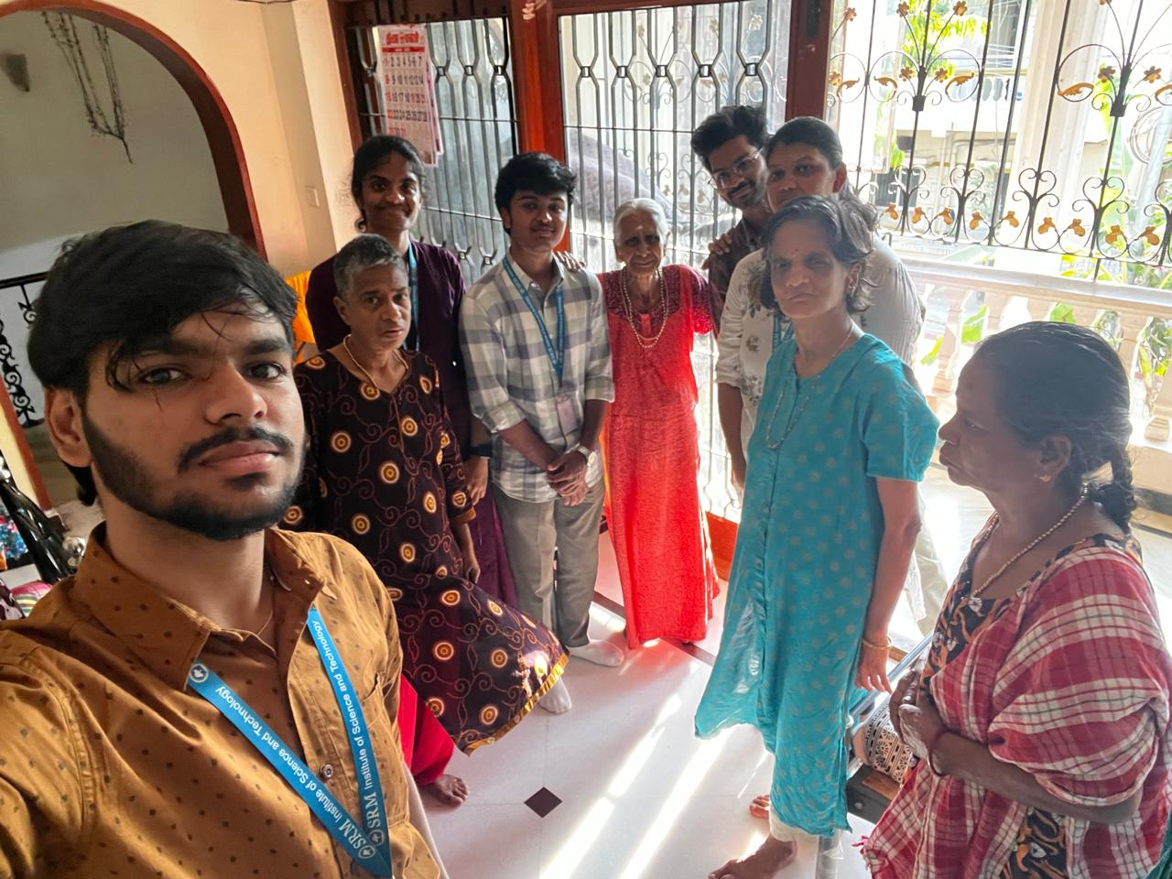

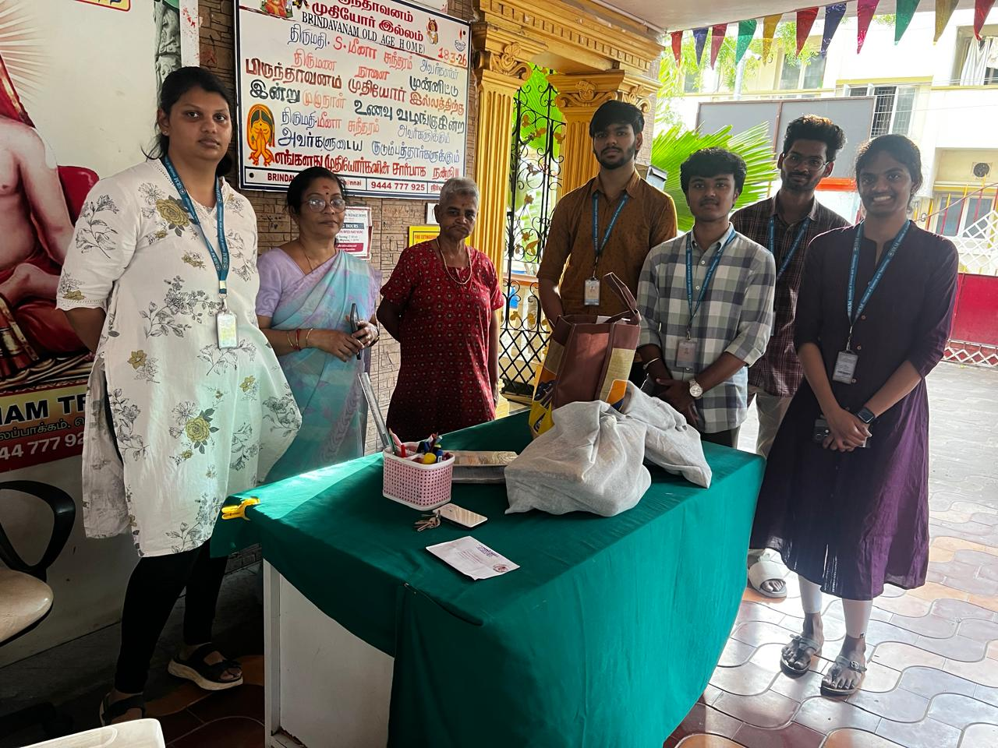

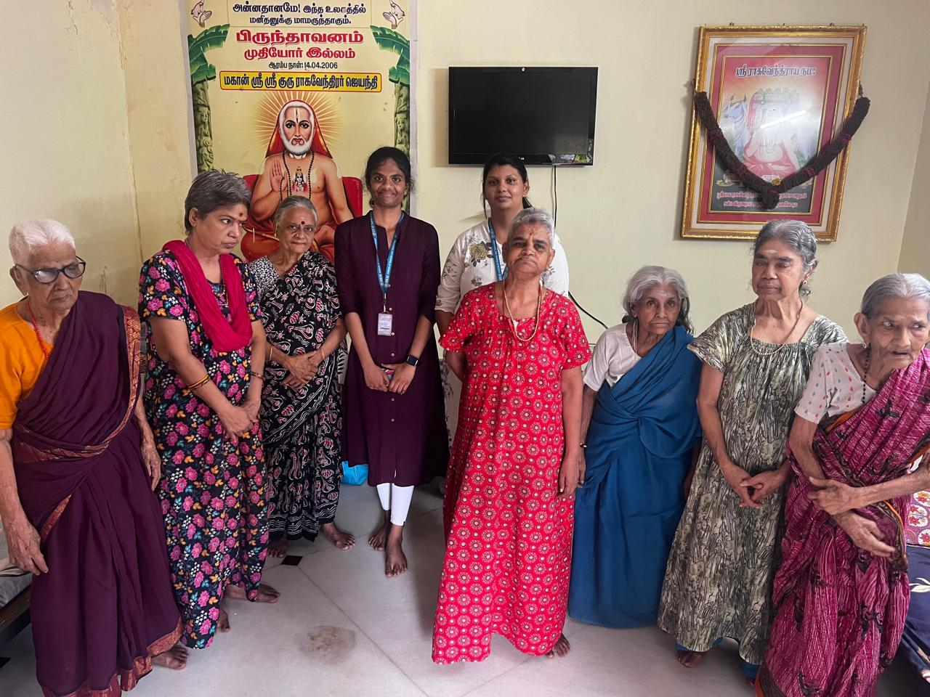
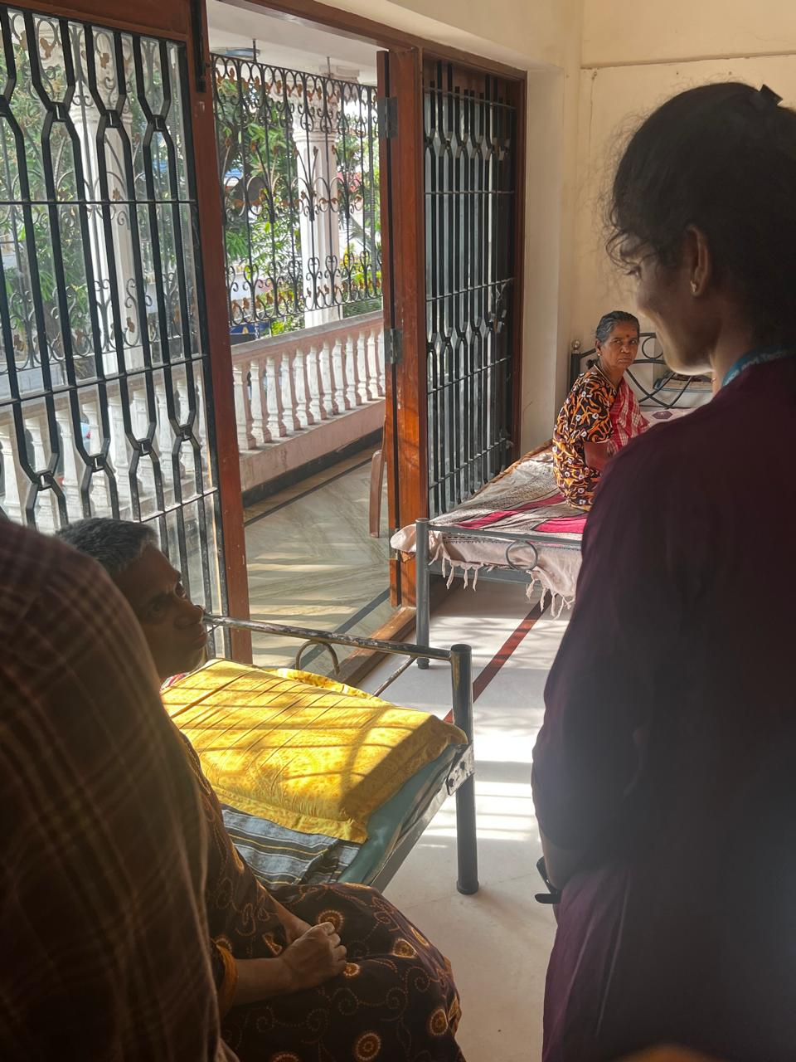

8.Appreciation and Gratitude

Furthermore, the visit helped us understand that gratitude is closely connected to our perspective on life. When we become more aware of the struggles and experiences of others, we begin to value our own lives more deeply. The elderly residents, despite their challenges, showed contentment in small things such as conversations, companionship, and simple acts of kindness. This taught us that happiness does not always come from material possessions, but from meaningful relationships and emotional connections.

The experience also encouraged us to develop a habit of acknowledging and appreciating the efforts of people around us—not only within our families but also in society. Caretakers, staff members, and volunteers at the old age home work tirelessly to ensure the well-being of the residents. Observing their dedication made us realize the importance of recognizing and valuing the contributions of others, no matter how big or small.

In addition, the visit made us more mindful of our words and actions. We understood that showing kindness, offering help, and expressing gratitude can positively impact someone’s emotional well-being. A simple conversation, a smile, or a gesture of respect can make a person feel valued and cared for. This awareness encouraged us to practice gratitude not only in thought but also through consistent actions.

The experience also helped us develop a sense of humility. It reminded us that life is unpredictable, and circumstances can change over time. This understanding made us more grounded and appreciative of the present moment. It also strengthened our belief in the importance of supporting one another as a community.

Overall, the visit left a lasting impact on our mindset and attitude. It reinforced that appreciation and gratitude are not just values to be learned academically, but qualities to be practiced daily. By being thankful for what we have and showing genuine care towards others, we can lead a more positive, fulfilling, and meaningful life while also contributing to the happiness of those around us.

We also realized that gratitude is not just about expressing thanks through words, but also through actions. Spending time with loved ones, showing respect to elders, and being emotionally supportive are meaningful ways of demonstrating appreciation. The visit encouraged us to be more caring, attentive, and respectful in our relationships.

Furthermore, the experience made us more aware of the efforts of caregivers and staff members who dedicate their time and energy to the well-being of the residents. Their commitment and compassion highlighted the importance of valuing and appreciating the contributions of others in society.

Overall, the visit reinforced that appreciation and gratitude are essential values for leading a positive and fulfilling life. By practicing gratitude in our daily lives, we can build stronger relationships, develop a positive mindset, and contribute to a more compassionate and understanding society.

9.Summary

In conclusion, the visit to the old age home was a profound and enlightening experience that greatly enriched our understanding of human values. It provided us with an opportunity to connect with elderly individuals, understand their challenges, and contribute to their well-being in a meaningful way. The interactions we had and the experiences we gained will remain with us as valuable life lessons.

The visit enhanced our awareness, empathy, and sense of responsibility towards society. It helped us realize the importance of caring for the elderly, respecting their experiences, and acknowledging their emotional needs. It also strengthened our understanding of ethical values such as compassion, gratitude, patience, and kindness, and highlighted the importance of practicing these values in our everyday lives.

Moreover, the experience encouraged us to reflect on our own attitudes and behaviors towards our family members and society as a whole. It inspired us to become more compassionate, respectful, and socially responsible individuals who are willing to contribute positively to the community.

Overall, this visit was not just an academic activity, but a meaningful journey of personal growth and self-realization. It motivated us to continue engaging in social service and to uphold human values in all aspects of our lives, thereby contributing to the creation of a more caring and harmonious society.
The experience significantly enhanced our awareness about ourselves and our surroundings. It encouraged us to reflect on our behavior, values, and responsibilities as individuals and as members of society. We learned that small acts of kindness, such as offering food, listening with patience, or simply spending time with someone, can create a meaningful impact.
Furthermore, the visit strengthened our understanding of ethical values such as empathy, respect, compassion, and selflessness. It highlighted the importance of practicing these values in our daily lives rather than just learning them theoretically. It also inspired us to actively participate in social work and contribute towards the well-being of others.
Another important takeaway from this experience was the importance of appreciation and gratitude. It reminded us to value our relationships, respect our elders, and be thankful for the support and opportunities we have in life.
Through this visit, we gained a deeper insight into the lives of elderly individuals and the various challenges they face, including loneliness, emotional distress, and lack of family support. At the same time, we also witnessed their strength, wisdom, and ability to adapt to difficult situations. This dual understanding helped us develop a more balanced and compassionate perspective towards life.

